Lab A1 – Flashlight Report

Reese Ford 09/05/2024

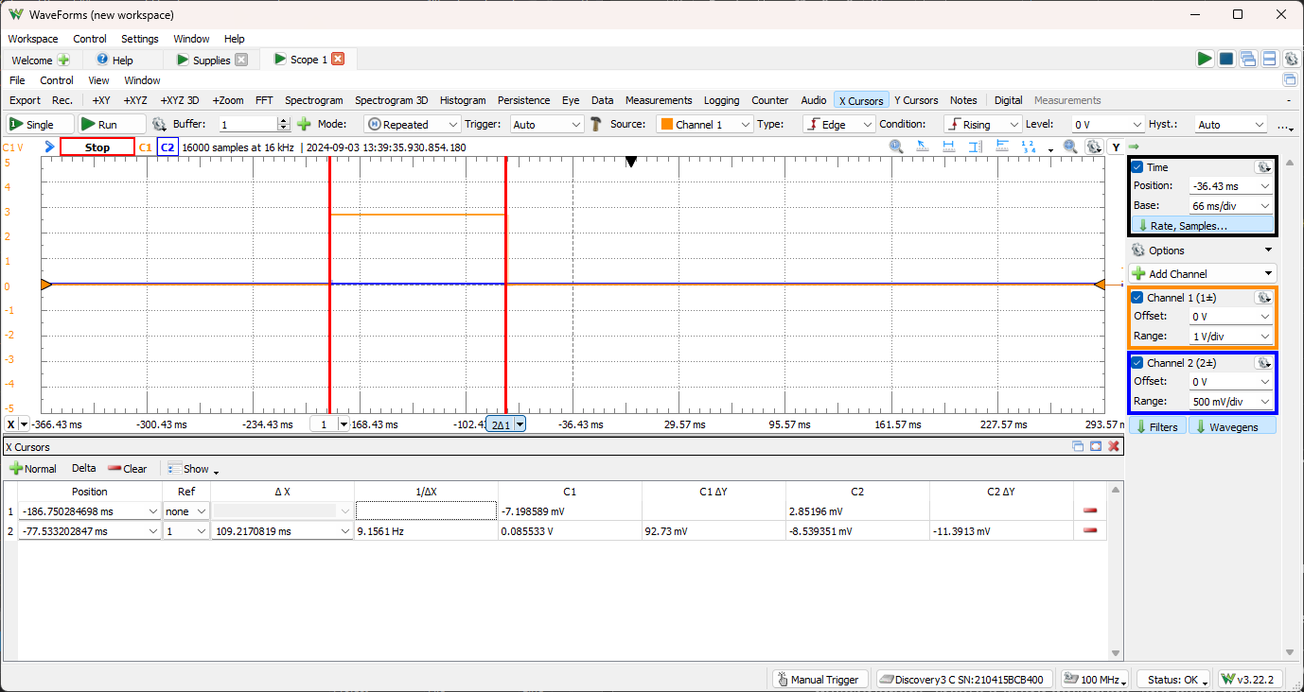

Figure 1: Part 3 - Breadboard Button Press

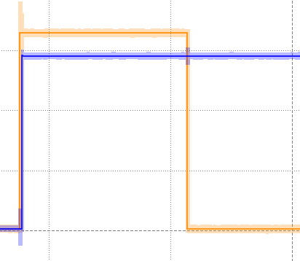

Figure 2: Part 4 - LED On

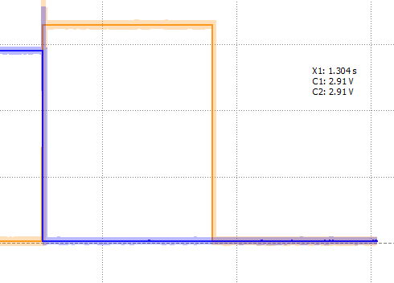

Figure 3: Part 4 - LED Off